DATA STRUCTURES & ALGORITHMS (23CS4111)
Assignment Set 2 - Programming
UNIT-III: Linked Lists

5.A department maintains student roll numbers dynamically. Write a C program using a Singly Linked List to create the list, insert at the beginning and end, search for a specified roll number, delete a specified roll number, and display the updated list after each operation. Handle the case when a requested roll number is not available.

Source Code:
#include <stdio.h>
#include <stdlib.h>

struct node {
int roll;
struct node *next;
};
struct node *head = NULL;

struct node *newNode(int roll) {
struct node *p = (struct node *)malloc(sizeof(struct node));
p->roll = roll;
p->next = NULL;
return p;
}

void insertBegin(int roll) {
struct node *p = newNode(roll);
p->next = head;
head = p;
}

void insertEnd(int roll) {
struct node *p = newNode(roll), *t;
if (head == NULL) {
head = p;
return;
}
for (t = head; t->next != NULL; t = t->next)
;
t->next = p;
}

void display() {
struct node *t = head;
if (head == NULL) {
printf("List is empty.\n");
return;
}
printf("List: ");
while (t != NULL) {
printf("%d -> ", t->roll);
t = t->next;
}
printf("NULL\n");
}

void search(int roll) {
struct node *t = head;
int pos = 1;
while (t != NULL) {
if (t->roll == roll) {
printf("Roll number %d found at position %d.\n", roll, pos);
return;
}
t = t->next;
pos++;
}
printf("Roll number %d is not available in the list.\n", roll);
}

void deleteNode(int roll) {
struct node *t = head, *prev = NULL;
while (t != NULL && t->roll != roll) {
prev = t;
t = t->next;
}
if (t == NULL) {
printf("Roll number %d is not available. Nothing deleted.\n", roll);
return;
}
if (prev == NULL)
head = t->next;
else
prev->next = t->next;
free(t);
printf("Roll number %d deleted.\n", roll);
}

int main() {
int choice, n, i, x;
do {
printf("\n1.Create 2.Insert at beginning 3.Insert at end\n");
printf("4.Search 5.Delete 6.Display 7.Exit\nEnter choice: ");
scanf("%d", &choice);
switch (choice) {
case 1:
printf("How many roll numbers? ");
scanf("%d", &n);
printf("Enter %d roll numbers:\n", n);
for (i = 0; i < n; i++) {
scanf("%d", &x);
insertEnd(x);
}
display();
break;
case 2:
printf("Enter roll number: ");
scanf("%d", &x);
insertBegin(x);
display();
break;
case 3:
printf("Enter roll number: ");
scanf("%d", &x);
insertEnd(x);
display();
break;
case 4:
printf("Enter roll number to search: ");
scanf("%d", &x);
search(x);
display();
break;
case 5:
printf("Enter roll number to delete: ");
scanf("%d", &x);
deleteNode(x);
display();
break;
case 6:
display();
break;
case 7:
printf("Exiting program.\n");
break;
default:
printf("Invalid choice!\n");
}
} while (choice != 7);
return 0;
}

Output:
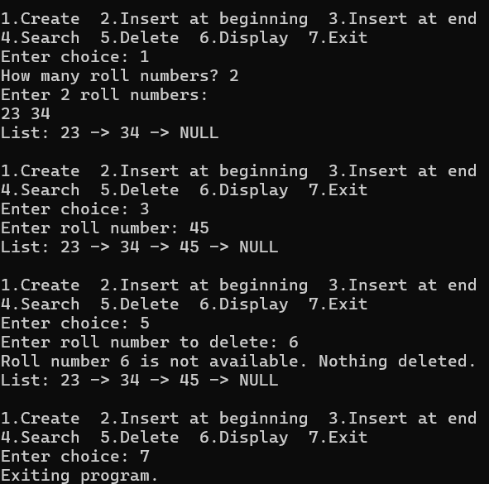

6. Develop a C program for a Doubly Linked List representing a sequence of web pages visited by a user. The program should insert a new page, move forward and backward, delete a specified page, and display the pages from first-to-last and last-to-first while handling beginning and end conditions correctly.

Source Code:
#include <stdio.h>
#include <stdlib.h>
#include <string.h>

struct page {
char url[50];
struct page *prev, *next;
};
struct page *head = NULL, *tail = NULL, *cur = NULL;

void visit(char url[]) {
struct page *p = (struct page *)malloc(sizeof(struct page));
strcpy(p->url, url);
p->next = NULL;
p->prev = tail;
if (tail == NULL)
head = p;
else
tail->next = p;
tail = p;
cur = p;
printf("Visited new page: %s\n", url);
}

void forward() {
if (cur == NULL)
printf("History is empty.\n");
else if (cur->next == NULL)
printf("End of history: already at the last page (%s).\n", cur->url);
else {
cur = cur->next;
printf("Moved forward to: %s\n", cur->url);
}
}

void backward() {
if (cur == NULL)
printf("History is empty.\n");
else if (cur->prev == NULL)
printf("Beginning of history: already at the first page (%s).\n", cur->url);
else {
cur = cur->prev;
printf("Moved backward to: %s\n", cur->url);
}
}

void deletePage(char url[]) {
struct page *p = head;
while (p != NULL && strcmp(p->url, url) != 0)
p = p->next;
if (p == NULL) {
printf("Page '%s' not found. Nothing deleted.\n", url);
return;
}
if (p->prev != NULL)
p->prev->next = p->next;
else
head = p->next; /* deleting first page */
if (p->next != NULL)
p->next->prev = p->prev;
else
tail = p->prev; /* deleting last page */
if (cur == p)
cur = (p->next != NULL) ? p->next : p->prev;
free(p);
printf("Page '%s' deleted.\n", url);
}

void displayForward() {
struct page *t = head;
if (head == NULL) {
printf("History is empty.\n");
return;
}
printf("First to Last: ");
while (t != NULL) {
printf("%s%s", t->url, (t == cur) ? "*" : "");
if (t->next != NULL)
printf(" <-> ");
t = t->next;
}
printf("\n");
}

void displayBackward() {
struct page *t = tail;
if (tail == NULL) {
printf("History is empty.\n");
return;
}
printf("Last to First: ");
while (t != NULL) {
printf("%s%s", t->url, (t == cur) ? "*" : "");
if (t->prev != NULL)
printf(" <-> ");
t = t->prev;
}
printf("\n");
}

int main() {
int choice;
char url[50];
printf("(* marks the current page)\n");
do {
printf("\n1.Visit new page 2.Forward 3.Backward 4.Delete page\n");
printf("5.Display first-to-last 6.Display last-to-first 7.Exit\nEnter choice: ");
scanf("%d", &choice);
switch (choice) {
case 1:
printf("Enter page name: ");
scanf("%s", url);
visit(url);
break;
case 2: forward(); break;
case 3: backward(); break;
case 4:
printf("Enter page name to delete: ");
scanf("%s", url);
deletePage(url);
break;
case 5: displayForward(); break;
case 6: displayBackward(); break;
case 7: printf("Exiting program.\n"); break;
default: printf("Invalid choice!\n");
}
} while (choice != 7);
return 0;
}

Output:
